Sales Accessory Maintenance

Before you can sell a sales accessory, you have to first create it through Sales Accessory Maintenance (See Figure 1) from the Rate Control menu. This screen allows for the definition of sales accessories and their associated fees and taxes. The sales accessory’s price may also be defined by location. These accessories can be referenced for use in contracts and reservations.

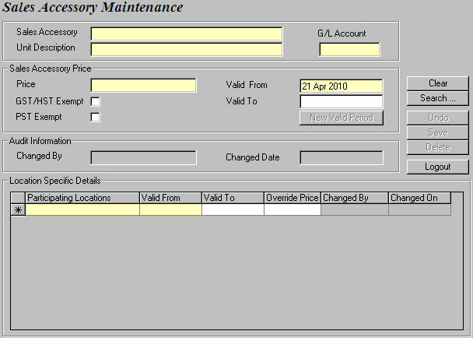
Figure 1: The Sales Accessory Maintenance screen.

Start creating your sales accessory by populating the Sales Accessory, Unit Description, Price, Valid From and To fields. You can also specify whether the sales accessory is exempt from GST/HST or PST. Enter the G/L Account. Note that this G/L Account Number should also be set up in the accounting software of your choice for reference.
NOTE
Account numbers in GIS are structured into three levels, as shown below.
Account Number
Vehicle Class Account Segment
Location Account Segment

NNNNN—XX—YY

Let’s use a 2’ cubic box as an example. Assume its account number is 6113.

- Simple account numbers without any dependencies on location or vehicle class will take the form of NNNN (where N is a string of digits). So you would enter only 6113 in the G/L Account field for 2’ cubic box.

- If your accounting is based on location, then your account number will omit the Vehicle Class Account Segment. So you would enter 6113-XX in the G/L Account field for 2’ cubic box. The XX is just a syntax and it will pick up the actual account segment from the Location Maintenance module.

- If your accounting is based on location and vehicle class, then you would enter 6113-XX-YY in the G/L Account field for 2’ cubic box. The YY is just a syntax and it will pick up the actual account segment from the Vehicle Class module.

Next, you may enter location specific information for your sales accessory. The locations that offer the sales accessory are added to the Participating Locations column. Then for each participating location, you can define a location specific price in the Override Price field. This new amount will override the Price you previously set in the Sales Accessory Price section. Audit information is visible for each sales accessory and for each participating location. Save all your changes.

To retrieve a sales accessory for modification, you can search by using the Sales Accessory name, Unit Description, or Valid From and To dates.

